**Introduction to Energy**

**Directions**:

1. After completing the stations, matching and readings, you will complete the following conclusions

**A. Station One-Part Three: Toys**

|  | Forms of Energy Observed |
| --- | --- |
| Toy Car |  |
| Balloon |  |
| Yo-Yo |  |

**Conclusion**

Using the forms of energy you observed, what transformations occurred?

|  | Energy Transformation |
| --- | --- |
| Toy Car |  |
| Balloon |  |
| Yo-Yo |  |

**B. Station 3: Part One: Sunlight and Shade**

**Conclusion**

Answer the following using complete and detailed sentences. Use data to support your reasoning.

Explain how direct light affects the temperature of an object. What energy transformations occurred? Use data to support your reasoning.

|  |
| --- |

**Use** [**this link**](https://nces.ed.gov/nceskids/createagraph/default.aspx?ID=1abc3a1e611149a283aa865285ba8df7) **to create a graph of this data. Use a line graph.**

1. **Make sure to title the graph and your axes**
2. **Set up the Data Set as shown:**

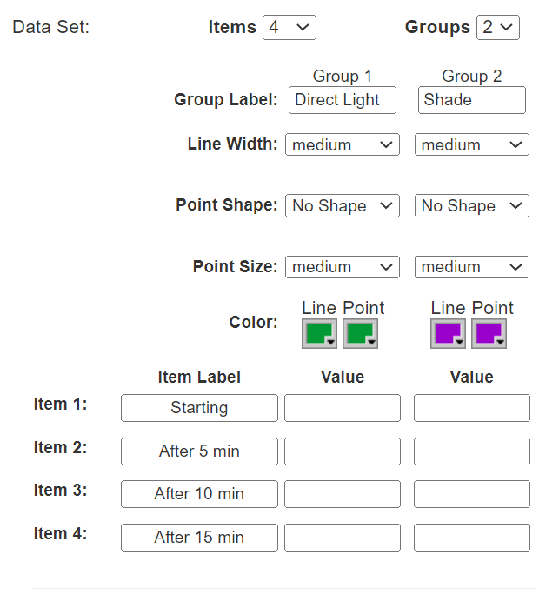

1. **Make sure to have no labels and include a legend**
2. **Paste graph below**

**C. Station Three- Part Two**

**Conclusion**

Answer the following using complete and detailed sentences. Use data to support your reasoning.

Explain how light affects a radiometer.Use data to support your reasoning.

What energy transformations occurred? Use data to support your reasoning.

|  |
| --- |

**D. Station Three- Part Three: Solar Panel**

**Conclusion**

Answer the following using complete and detailed sentences. Use data to support your reasoning.

Explain how changing the angle of the solar panel affected electricity production.Use data to support your reasoning.

What energy transformations occurred? Use data to support your reasoning.

|  |
| --- |

**E. Station Five- Part One: Glow Sticks**

**Conclusion**

Answer the following using complete and detailed sentences. Use data to support your reasoning.

Explain how temperature affected the rate of the chemical reaction in the glow stick. Use data to support your reasoning.

What energy transformations occurred? Use data to support your reasoning.

|  |
| --- |

**F. Station Six-Part Two: Hand Generated Flashlight and Motors**

**Conclusion**

Answer the following using complete and detailed sentences. Use data to support your reasoning.

Compare a hand generated flashlight and a motor. Describe the similarities and differences. Use data to support your reasoning.

What energy transformations occurred? Use data to support your reasoning.

|  |
| --- |